OTP Request REST Service

# Background

TSP can request an OTP for an individual, which can be used to perform OTP based authentication using OTP Request API for that Individual.

## Target users -

TSP will request for an OTP on behalf of an Individual

## Key requirements -

* TSP can authenticate an Individual using OTP sent to the Individual by OTP Request API
* TSP will capture Individual’s UIN/VID and construct OTP Request
* Once OTP Request is received, authenticate and authorize TSP
* Check Individual’s UIN/VID for authenticity and validity
* Create and send OTP to the Individual via message and/or email

## Key non-functional requirements -

<< TBD >>

# Solution

OTP Request REST service addresses the above requirement.

1. TSP to construct a **POST** request with below details and send to Request URL **identity/otp**

Sample Request Body –

{

"id": "mosip.identity.otp",

"ver": "1.0",

"indId": "1234567890",

"indIdType": "D",

"muaCode": "tspLevel1ID",

"reqTime": "2018-10-12T09:45:49.565Z",

"txnID": "txn12345"

}

1. Authenticate and Authorize TSP <<TBD>>
2. Validate “reqTime” for incoming OTP Requests for valid format and timestamp < 20mins from current time
3. Integrate with kernel UIN Validator and VID Validator to check UIN/VID for validity. Validate UIN/VID for authenticity in AuthDB
4. Create OTP using OTP key in the format using OtpUtil- *<product_id>_<uin_ref_id>_<txn_id>_<mua_code>*
5. Retrieve mode of communication with Individual using admin config to send generated OTP
6. Integrate with Kernel SmsNotifier and EmailNotifier to send the generated OTP to their stored phone/email respectively.
7. Respond to TSP with below success OTP generation response -

{

"status": true,

"err": [],

"resTime": "2018-10-12T09:45:49.580Z",

"txnID": "txn12345"

}

## Class Diagram:

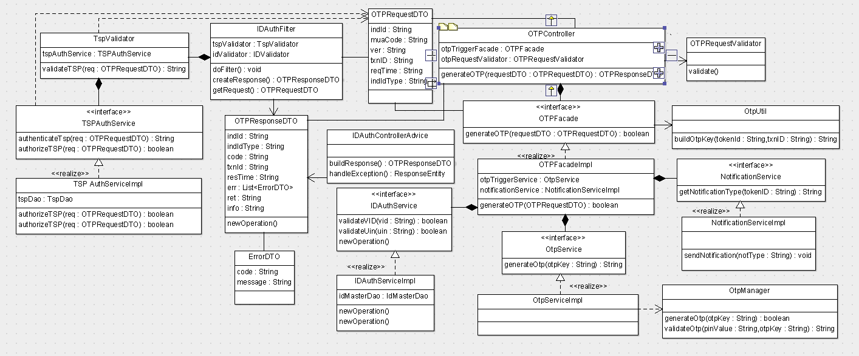

Below are details on the above classes –

* **OTPRequestDTO** – Request object with input request for OTP
* **OTPResponseDTO** – Response object with success or failure to generate and send OTP
* **IDAuthFilter** – Spring filter to intercept OTP Request and Response in order to authenticate/authorize TSP
* **OTPController** – Spring Controller to receive OTP Request
* **OTPRequestValidator** – Spring Validator to validate input request object OTPRequestDTO
* **OTPFacade** – Sprint Component that acts like facade layer to validate UIN/VID and invoke OTPService to process OTP request
* **OTPService** – Spring Service that interacts with OTPManager and OTPUtil to generate OTP
* **OTPManager** – Manager class to integrate with Kernel Generate OTP and Validate OTP Rest APIs
* **OTPUtil** – Utility class to generate unique key to be used to generate OTP
* **IDAuthControllerAdvice** – Spring Controller Advice used to handle all exceptions and send corresponding error response
* **IDAuthService** –Spring Service that validates UIN and VID for its authenticity
* **NotificationService** – Sprint Service whichwhich is created in another user story and used here to send generated OTP to individual as SMS or Email.

## Sequence Diagram:

